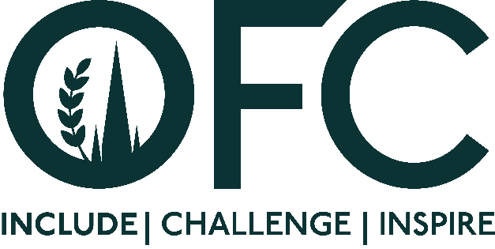
Press Release
[3 October 2023]

Oxford Farming Conference reveals speakers for OFC24

Tickets have gone on sale for the Oxford Farming Conference (OFC) and a list of headline speakers has been released, including environmentalist and financier Ben Goldsmith, chef, broadcaster and writer Romy Gill MBE, farmer and musician Andy Cato, and Chair of Westmorland Limited, Sarah Dunning. They join more than 30 speakers who will be attending the event from 3 to 5 January 2024.
Multi-millionaire Ben Goldsmith, a controversial figure among the rural community for views on subjects such as subsidies and the impact of farmed animals on the environment, will put forward the motion This house believes that farming for food is holding back nature recovery in protected landscapes in the always highly anticipated conference debate in the hallowed setting of the Oxford Union. Cumbrian hill farmer Will Cockbain will lead the opposition to the motion.
Romy Gill MBE is a renowned Indian chef, broadcaster, and food and travel writer. Her versatility and engaging style have led to appearances on shows such as James Martin's Saturday Morning, Country File, Celebrity MasterChef, The Hairy Bikers' Comfort Food, Celebrity Pointless, with guest slots on Channel 4's Packed Lunch and Sunday Brunch and BBC's The One Show.
Andy Cato, co-founder of Wildfarmed, is a mixed arable and livestock farmer. He was awarded the 2020 Laureate Nationale for innovation in agroecology and the Chevalier de l’Ordre du Mérite Agricole for his work in France. Now back on British soil and farming as a tenant of the National Trust, Andy is on a mission to help farmers move towards soil-focused farming whilst making real food grown in real soil available on the high street at affordable prices.
Chair of OFC24, Welsh beef and arable farmer Will Evans, said tickets going on sale and the announcement of speakers for the event has set the countdown clock ticking.
“It was very exciting - but also slightly daunting - to see the tickets going on sale,” says Will.
“What the conference does so well is challenge its audiences; putting speakers on stage saying things that we as an industry don’t necessarily want to hear.”
One speaker Will is very much looking forward to hearing is Sarah Dunning OBE. Her parents launched Tebay Services in 1972 after the M6 motorway was built across their Cumbrian hill farm. It has grown to a nationwide concern but remained true to its agricultural roots by working with local farmers and producers.
“We’ve all probably pulled off the motorway at Gloucester, or one of the family’s other service stations, and it will be so interesting to hear the backstory to this farming family’s amazing success story,” said Will.
The theme of diversity for the 2024 OFC came to Will while he was driving his tractor.
“I hope diversity will be a lasting legacy, rather than a theme that is tackled and then forgotten about,” he explained.
“It’s very much my hope that we can go forwards united in making agriculture a destination industry for people from a diversity of backgrounds.
“Of course, agriculture is already full of diversity - in its environment, landscapes and the food it produces - so it’s a much wider theme than just about the people within the industry. I want the whole conference to be a celebration of difference. There are no right or wrong answers; but diversity of opinions that we might not agree with but that are very much worth listening to.”

Other keynote speakers will include Caroline van der Plas, the party leader of the Farmer Citizen Movement (BBB, BoerBurgerBeweging) in The Netherlands. BBB won a landslide victory in the regional elections in March 2023, becoming the biggest party in the provinces and winning 16 seats in the senate.
Travelling in from overseas will be Dr Diana Onyango, a veterinary doctor with over 20 years of experience improving the livelihoods, resilience, and food security of communities in the Horn of Africa.

Farmer Douglas Wanstall from Kent will shine a light on how he is moving back to the future, reintroducing livestock into his farming business with the overall aim of developing a truly circular agricultural system. Doug has also developed a wedding business and been instrumental in the development of the UK Carbon Code of Conduct, a mechanism to bring rigour to the voluntary carbon market.

Fifth-generation dairy farmer Jimmy Shanks will be speaking about becoming Scotland’s only producer of tomatoes, something that many doubted was even possible.

Continuing the theme of succeeding through adversity, Michael Duxbury was the first blind person to go to an agricultural college back in the 1980s. Following a successful career as a pig and feed speciality, he went on to set up Inclusive Farm, a project designed to teach agriculture to other disabled students, whilst also highlighting their abilities to the industry.

Jan McCourt is a farmer, born of Irish parents. In 1997, Jan went from being an Investment Banker to a full-time farmer and running the farm shop on the family farm and at Borough Market in London. He will share his journey and how taking a rural business, to an urban area has reaped rewards for him and his family.

To view a full list of speakers or purchase a ticket for OFC24, taking place from 3 to 5th January 2024, visit www.ofc.org.uk.

ENDS

Issued by Jane Craigie Marketing. For further details or interviews, please contact marketing@ofc.org.uk or phone Rebecca on 07792 467730.

Notes to Editors:

- For more information on the Oxford Farming Conference (OFC):
Website: www.ofc.org.uk
Twitter: @oxfordfarming
YouTube: OxfordFarmingConference

- The OFC is one of the only external events to be allowed to host a debate in the Oxford Union. It has a long and proud history going back to 1936 and a strong reputation as one of the UK’s leading agricultural events. It always takes place in Oxford in the first week of January and is based at the Oxford Examination Schools. It offers a vibrant programme of speakers, panel and politics sessions as well as networking.

- Will Evans, a tenth-generation farmer, is well-known for his award-winning podcast Rock & Roll Farming, showcasing agriculture and the people involved to the wider public. He is married to a farmer, is father to four daughters and writes a weekly column for the Farmers Weekly.

- Early Bird Tickets for the OFC, priced at £320 exc VAT, are available via www.ofc.org.uk There is a digital ticket option at £75 exc VAT. Awareness about cost of living pressures facing delegates mean that in spite of rising costs there has been no increase in ticket prices. More than 40 individuals under the age of 30 will be supported to attend through bursaries and scholarships.

- OFC is a charity that invests in agricultural education and knowledge-sharing. It attracts over 650 delegates every year, including many people from the wider food chain, retail, NGOs, scientific organisations, media, policy-making bodies and governments from around the world.

- HRH Princess Royal is patron of the OFC.

